E-Housing Society

Chapter-1

Study of Existing system and system requirements.
Hardware & Software Requirement:

Hardware Interfaces
- Minimum Hardware requirement
- Processor: P4 3.0 GHz
- RAM:1 GB or Higher
- Monitor
- Mouse
- Hard disk: 80 GB

Software Interfaces
- Minimum Software requirement
- Java (JSP and Servlet)
- Apache Tomcat Server

All these types of software automatic configure inside operating system after installation it having Java, MYSQL, Apache and operating system base configuration file, it doesn’t need to configure manually.
Introduction
This application is intended to manage all the activities of E-Housing Management. Admin is the main user of the website who will manage every activity. This project is developed in Java and the database used here is MYSQL using MVC architecture. In the backend, we have used Servlet. This application provides end to end solution for renting, allocating Houses and, etc.
This online platform of the E-Housing Management system will help the user to sell or rent their Houses online. Here, this system has all the functionality to effectively manage the working of the Housing society. This system has replaced the manual process of entering the information of society and its houses in a book with an automated online process. Through this application, the admin can view, add and Manage members and society effectively.
Objective
E-Housing Society Management System is developed to provide the solution of renting and selling the Houses and managing every activity of society through an application. Through, this application admin who is one of the users of this application will manage all the activities of creating a new society, adding houses to the society, viewing the report for the house, and so on.
The main Objective of the E-Housing Society Management System is to provide an online platform where a member of the society can use this application to raise complain related to society also if any member wants to sell or rent their Houses so they can use this application for that purpose also. This application can be used by the admin to add the houses, society and to allocate society to members. This application not only helps the admin but also the flat owners, who want to have the central system for their Hosing through online medium.
This project provides a simple and beautiful interface for the admin as well as to the member, or users. Just admin needs to add Society, add Houses to society, and allocate Houses to members and to generate reports and, etc. All the information will be stored in the database and that will help to maintain all the information of members.

Methodologies
There are two main users or actors in this application. Let’s see on by one
- Admin
- Users/Members
Admin is the main user here who will manage all the activity such as
- Admin can ADD members
- Admin can ADD/VIEW/UPDATE/DELETE Society.
- Admin can ADD/VIEW/UPDATE/DELETE Houses to Society.
- Admin can VIEW House report.
- Admin can Allocate House to member
- Admin can ADD members.
- Admin can view and reply to complain made by User/member.
User/Member is the users of this application who will sell, rent their Houses and also can generate complain.
- User can VIEW the House List.
- User can VIEW the Society List.
- User can rent the House.
- User can sell the House.
- User can manage its account Info.
- User can make new complain and can view the reply by Admin or owner.

Chapter-2
System Analysis
2.1 E R DIAGRAM:

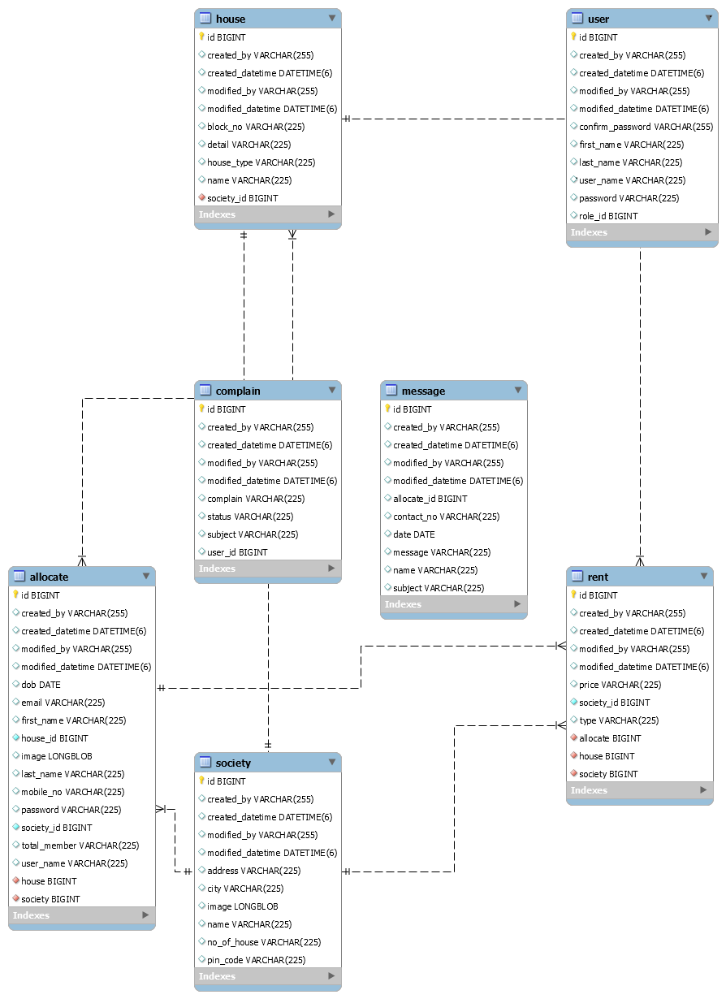

Data Flow Diagram (DFD) Level 0
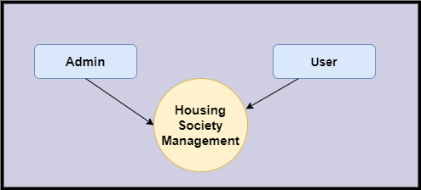

Level 1 DFD
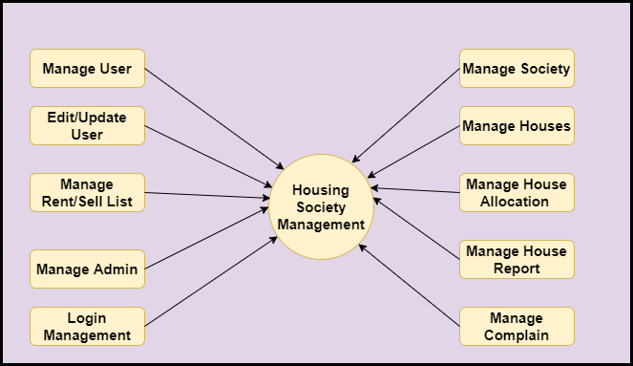

Level 2 –DFD Admin
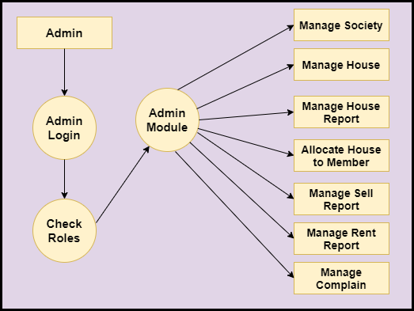
Level 2- User
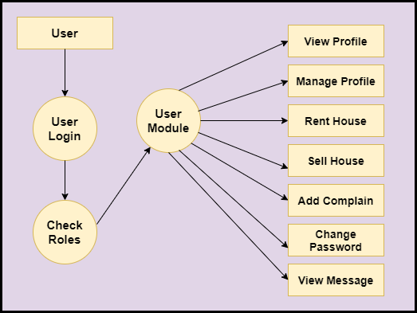
Functional DFD:
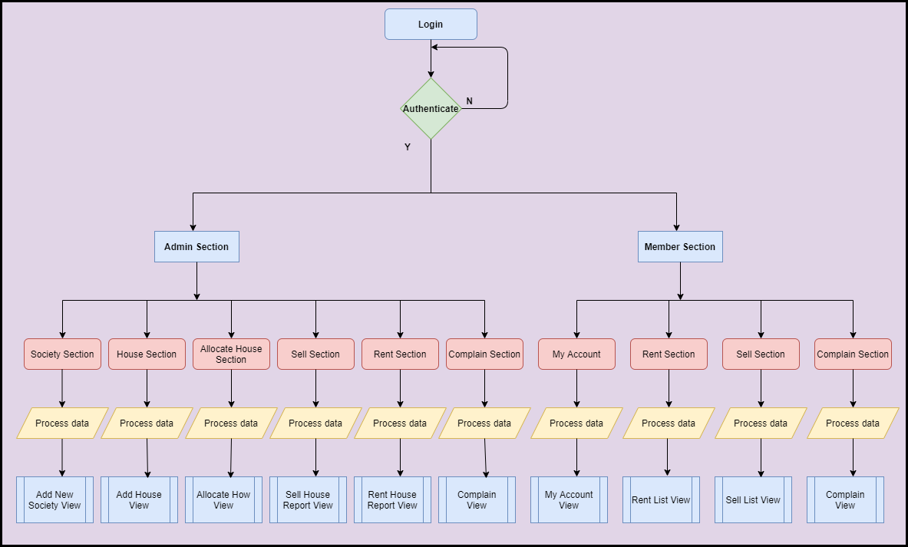
Feasibility:
This project will be developed on computer, so first check whether the technology is technically available or not. Now a day’s computer interaction with any job becomes common for any kind of job or work.

And because of increasing usage of Computer, Computer is also available with a variety of hardware. Vendors can fulfill any type of hardware requirement. The whole project is developed by some special tools or by using languages and databases, which are also available in a variety.

Preliminary investigation of a system examines the feasibility of a system that is useful to an organization. It is the first phase of system development.

The main objective of this phase is to identify the current deficiencies in the user’s environment and to determine which existing problem are going to be solve in proposed system and also which new function needs to be added in proposed system.

An important outcome of such preliminary investigation is to determine whether the system that will meet all needed requirements.

Thus, three tests are carried out on the system namely operation, technical and economical.

Any project is beneficial if and only satisfies the organization requirement. For any new system setup, it only meets to be communicated and work the other supporting system.

The new system meets all existing operations since it provides right information at a right time to the right user. A Leigh man can easily operate with the system.

Technical Feasibility examines whether the technology needed is available and if it is available then it feasible to carry out all project activities.

The technical needs of a system include:

- The facility to produce outputs in a given time.
- Ability to process large number of transaction at a particular speed.
- Giving response to users under certain conditions.

The technology needed for our system is mainly:

- Latest version of browsers.
- Any operating system.

These technologies are available which helps to carry out the system efficiently.

Economical feasibility of a system examines whether the finance is available for implementing the new system and whether the money spent is recoverable the satisfaction.

The cost involves is in designing and developing a good investment for the organization.

Thus, hardware requirements used for proposed system are very standard. Moreover, by making use of proposed system to carry out the work speedily will increase and also saves the valuable time of an organization.

In the proposed system the finance is highly required for the installation of the software’s which can also be recovered by implementing a better system.

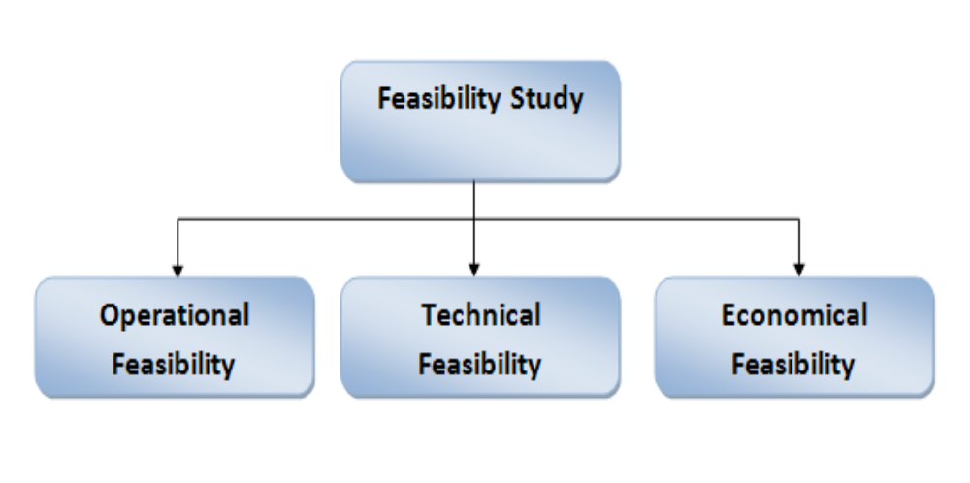

Chapter-3
Design

Data dictionary
Data validation:
Procedures are designed to detect errors in data at a lower level of detail. Data validations have been integrated in the system in almost every area where there is a possibility for the user to commit errors. The system will not recognize invalid data.
Whenever an invalid data is keyed in, the system immediately prompts the user and the user has to again key in the data and the system will accept the data only if the data is correct. Validations have been integrated where necessary.
The system is designed to be a user friendly one. In other words the system has been designed to communicate effectively with the user. The system has been designed with pop up menus.

Different Type Of validation:
- Data type validation;
- Range and constraint validation;
- Code and Cross-reference validation; and
Structured validation

Coding
Implementation and Testing:
Black-Box Testing:

Black Box Testing, also known as Behavioural Testing, is a software testing method in which the internal structure/ design/ implementation of the item being tested is not known to the tester. These tests can be functional or non-functional, though usually functional.

This can be following way:

- Input interfacing
- Processing
- Output interfacing
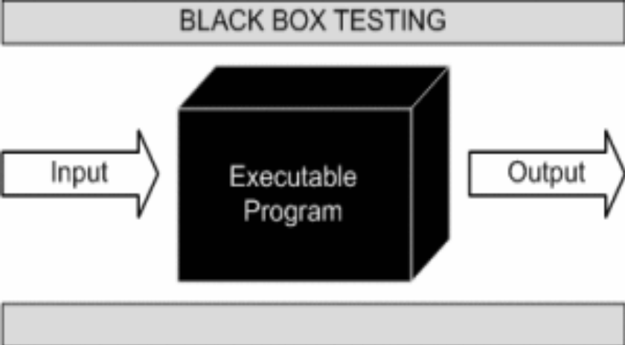

This method is named so because the software program, in the eyes of the tester, is like a black box; inside which one cannot see. This method attempts to find errors in the following categories:

- Incorrect or missing functions

- Interface errors

- Errors in data structures or external database access

- Behaviour or performance errors

- Initialization and termination errors.

White-Box Testing:

White Box Testing ,also known as Clear Box Testing, Open Box Testing, Glass Box Testing, Transparent Box Testing, Code-Based Testing or Structural Testing is a software testing method in which the internal structure/ design/ implementation of the item being tested is known to the tester.

The tester chooses inputs to exercise paths through the code and determines the appropriate outputs. Programming know-how and the implementation knowledge is essential.

White box testing is testing beyond the user interface and into the nitty-gritty of a system.
This method is named so because the software program, in the eyes of the tester, is like a white/ transparent box; inside which one clearly sees.

Screen Snapshot

Limitations and Future Application of the Project

Futures Enhancement:

- In future we can expand this project on the web.
- Software can be accessed through internet also.

Limitation :

- This application as of now doesn’t have online payment facility for the user.

Conclusion
This application thus provides easy access to an individual member of the society to register the complaint or if they want to sell their Houses or rent their house they can use this application. If in future admin wants to add new society they can add it easily. Thus, this application will automate the overall process and provide every functionality at ease.
This application is designed in such a way that any future modification can be done in an easiest way.

